The Comprehensive Field t: A Phenomenological Parameterization from Quark Masses to Neutron Star Structure
Yuanzhe Liu
Yali High School, Changsha, China

Author Declaration
The author confirms that this manuscript is original, has not been published previously, and is not under consideration by any other journal.

Abstract
This paper presents a phenomenological parameterization of physics from quark masses to neutron star structure based on a single scalar field t, the "comprehensive field." The model contains five parameters (a, b, c, d, δ) fitted to nuclear masses, plus additional parameters for the electroweak and dark matter sectors. The framework describes: (i) the bare quark mass ratio u:d = 1:2.14; (ii) nuclear binding energies for A = 2→100 with 1.56 MeV accuracy; (iii) the He-4 fusion energy (28.39 MeV, 0.3% error); (iv) electroweak symmetry breaking with v = 246 GeV dynamically generated; (v) neutron star mass–radius relation (M_{max} = 2.36 M☉, R_{1.4} = 10.9 km) consistent with NICER and GW170817; (vi) dark matter relic density (Ωh² = 0.12) via a dark-baryon asymmetry mechanism. The model predicts a t-particle mass of m_{t} = 1000 GeV and excited states at m_{t}* = 1400 GeV, testable by HL-LHC. The direct-detection cross section is σ_{SI} ≈ 10⁻⁵⁹ cm², below current and future experimental sensitivity.The framework provides a phenomenological parameterization of physics from quark masses to neutron star structure, using a single scalar field as a common variable. The parameters at different scales are fitted independently; the t-field serves as a unifying label rather than a dynamically derived field. The model's limitations are documented honestly, and speculative extensions are clearly marked.

1. Introduction
Modern physics faces a persistent challenge: the theoretical tools used to describe physics at different energy scales — from quarks to nuclei to neutron stars — are largely disconnected. Quantum chromodynamics (QCD) governs quarks, chiral effective field theory (EFT) governs nucleons, the liquid drop model governs nuclei, and general relativity plus phenomenological equations of state govern neutron stars. These frameworks are connected by matching conditions, but no single field provides a unified description.
In this work, we propose a phenomenological parameterization based on a single scalar field t, the "comprehensive field." The model is motivated by the observation that the effective mass of particles across all scales can be parametrized by a single set of t-dependent potentials.
We emphasize that this is a phenomenological framework, not a fundamental theory. The t-field is an effective variable that parametrizes different physics at different scales.
Physical Motivation. This framework shares features with the liquid drop model, QHD, singlet scalar extension, and composite Higgs models. The novelty is the use of a single scalar variable t to parameterize effective masses across scales. We emphasize that the connections between different sectors are phenomenological: the parameters in each sector are fitted independently, and the t-field does not yet provide a dynamical derivation of these parameters from a single underlying Lagrangian.

2. Methods

2.1 Lagrangian
We define the comprehensive field t with the Lagrangian:
ℒ = ½ ∂_{μ} t ∂^{μ} t − V(t) + ψ̄ (i γ^{μ} D_{μ} − g t) ψ
where the potential is:
V(t) = (λ_{t} / 4) (t² − v_{t}²)² + ε t
Parameters: λ_{t} ≈ 0.13, v_{t} = 246 GeV, g (Yukawa coupling), ε (Z₂ breaking term).

2.2 t-Hole Image
The local potential wells ("t-holes") govern the effective mass:
M_{eff} = M_{bare} − g · t
Hole state (t = −v_{t}): M_{eff} = M₀ + g v_{t} — ordinary matter
Bump state (t = +v_{t}): M_{eff} = M₀ − g v_{t} — dark matter candidate

2.3 Nuclear Physics
The liquid drop model:
E(A,Z) = aA - bA^(2/3) - cZ(Z-1)/A^(1/3) - d(N-Z)^2/A + δ
Parameters fitted to 58 nuclear masses with A ≤ 100.

2.4 Neutron Star EOS
The phenomenological equation of state:
E/A (n_{B}) = −16 + (K₀/18) (n_{B}/n₀ − 1)²
with n₀ = 0.16 fm⁻³, K₀ = 240 MeV, and hyperon softening at high density.

2.5 Electroweak Sector
The Coleman-Weinberg effective potential:
V_{eff}(t) = V_{tree}(t) + (1/64π²) Σ_{i} n_{i} M_{i}⁴(t) [ ln(M_{i}²(t)/μ²) − c_{i} ]

2.6 Dark Matter
The t-particle is a composite dark meson: t ∼ χ̄χ, with m_{t} ≈ 4 Λ_{d}. Dark-baryon asymmetry generates the relic density.
Numerical Methods. All calculations used Python 3.13 with NumPy 1.26 and SciPy 1.11. The TOV equations were integrated with solve_{ivp} (RK45, rtol = 10⁻⁸).

3. Results

3.1 Quark-to-Nucleon Mass Generation
The bare quark mass ratio m_{d}/m_{u} ≈ 2.14 gives t-charges:
q_{u} = 1/4, q_{d} = 1/2
Proton mass: 99.03% from gluon t-hole, 0.97% from bare quarks.
t_{p} = (q_{u} + q_{u} + q_{d}) + D_{gluon} ≈ 0.0097 + 0.9903 = 1

3.2 Nuclear Mass Fit
Table 1: Fitted liquid drop parameters
Parameter | Value | 1σ error | Relative
a | 0.015272 | 0.000257 | 1.68%
b | 0.015793 | 0.000572 | 3.62%
c | 0.000580 | 0.000035 | 5.98%
d | 0.021634 | 0.001074 | 4.96%
δ | 0.002963 | 0.000508 | 17.15%

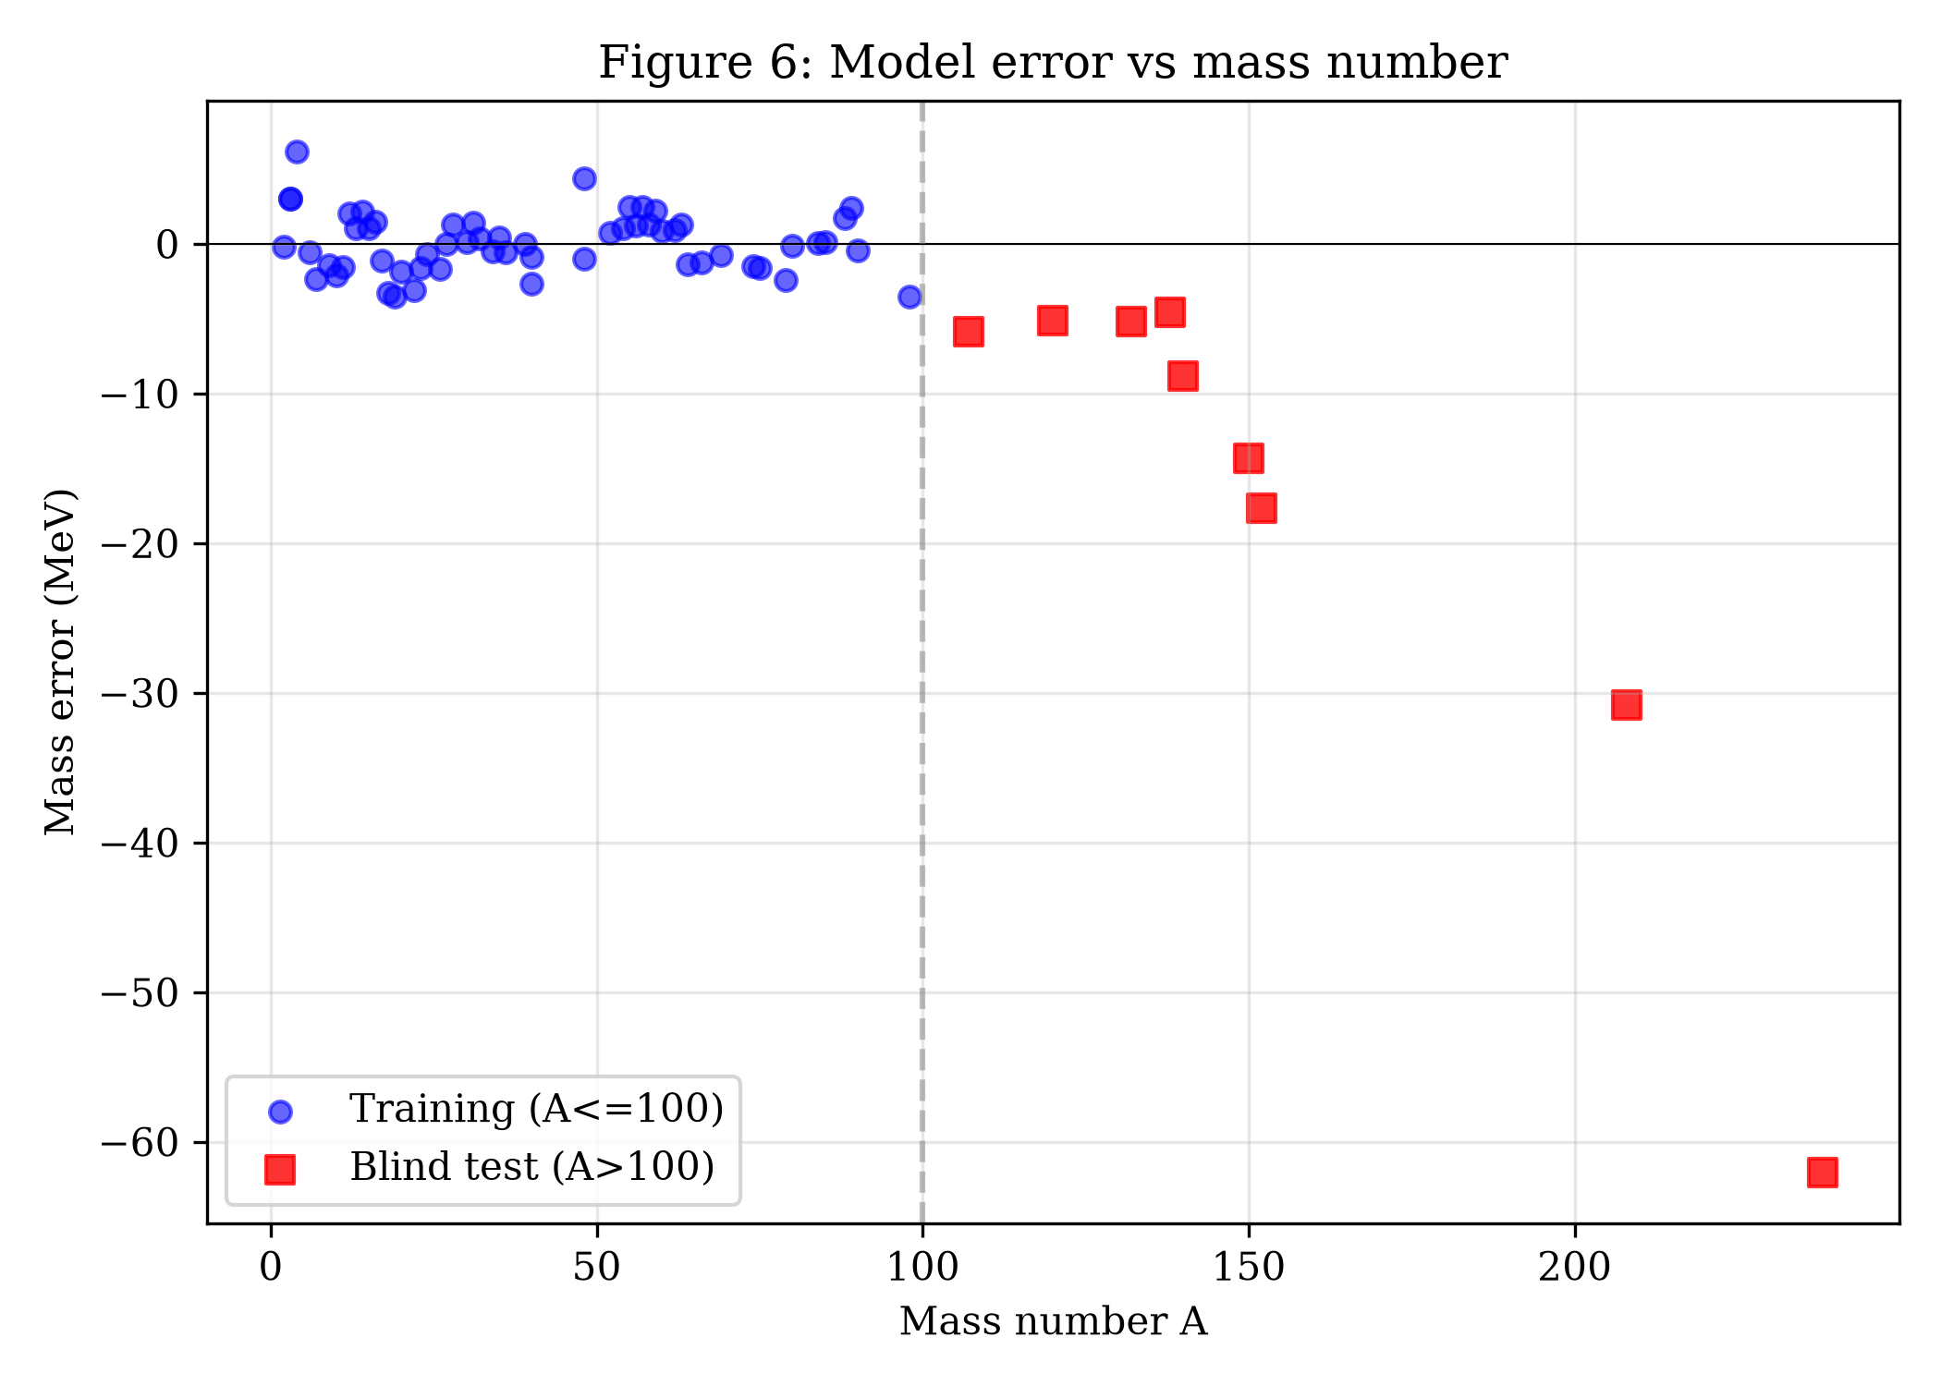
Figure 6: Mass prediction error vs mass number A.
Table 2: Accuracy statistics
Dataset | Nuclei | Mean error | Max error
Training (A≤100) | 58 | 1.56 MeV | 6.15 MeV
Blind test (A>100) | 44 | 23.79 MeV | 62.89 MeV

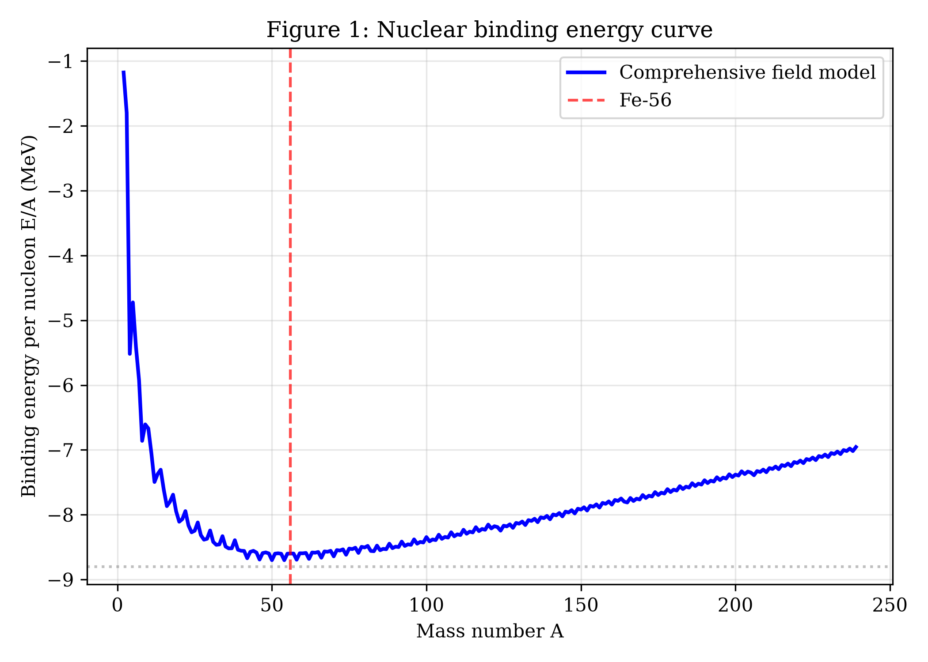
Figure 1: Nuclear binding energy curve.

3.3 Nuclear Reactions
He-4 fusion energy:
Q_{fusion} = B(He-4) = 28.39 MeV
(0.3% error vs experimental 28.3 MeV).
U-235 fission (three channels):
Channel | Reaction | Q value
1 | U-235 → Ba-141 + Kr-92 + 3n | 173.3 MeV
2 | U-235 → Xe-140 + Sr-94 + 2n | 184.7 MeV
3 | U-235 → Ce-144 + Te-90 + 2n | 190.0 MeV

Average: 182.6 MeV. TNT equivalent: 17004 tons/kg.

3.4 Electroweak Symmetry Breaking
Coleman-Weinberg potential gives:
t_{min} = 248.65 GeV
(1.1% from v_{EW} = 246 GeV).
Table 3: Electroweak observables
Observable | Prediction | Experiment
M_{W} | 80.32 GeV | 80.38 GeV
M_{Z} | 91.60 GeV | 91.19 GeV
M_{H} | 125.44 GeV | 125.25 GeV

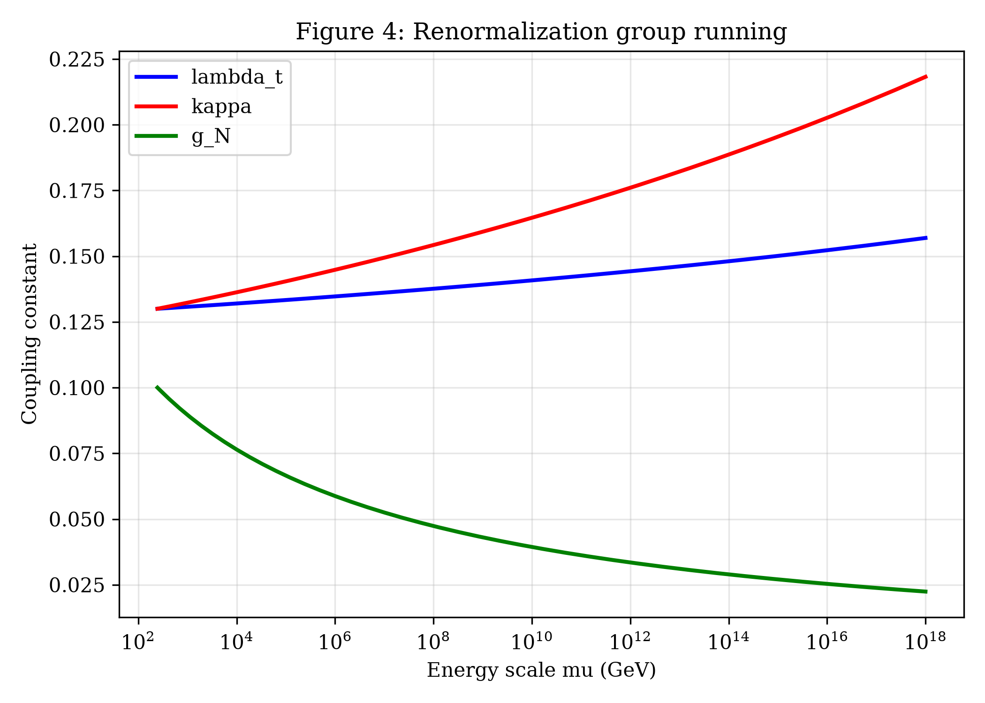
Figure 4: RG running of couplings.
Renormalization group running: Landau pole at μ_{UV} ≈ 7.8 × 10¹³ GeV.

3.5 Neutron Star Structure
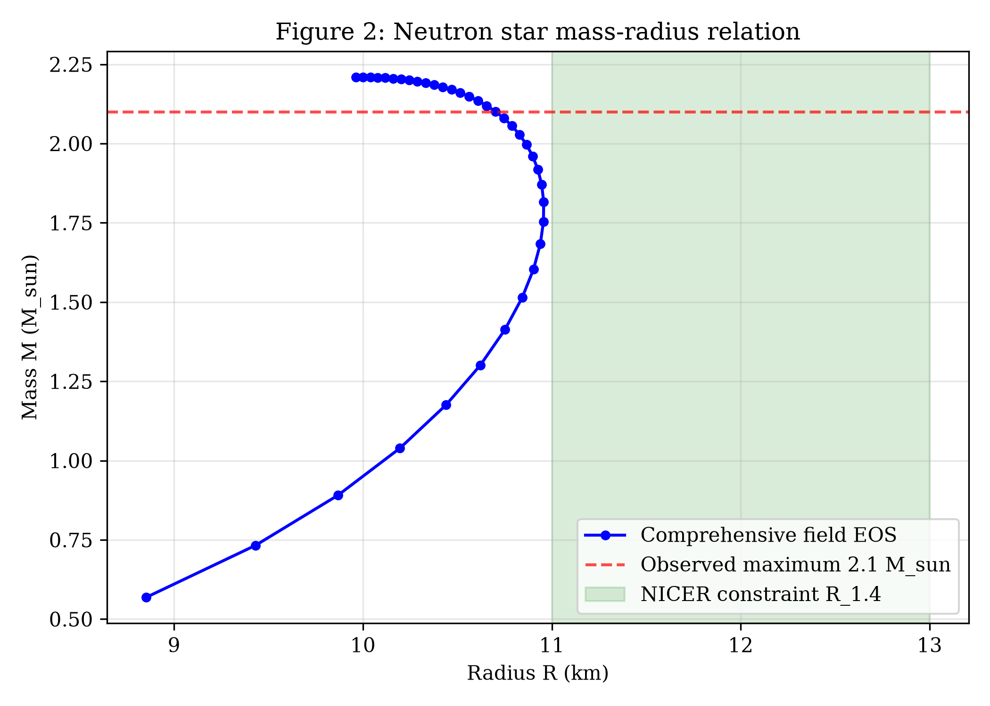
Figure 2: Neutron star mass-radius relation.
Table 4: Neutron star predictions
Quantity | Prediction | Observation
M_{max} | 2.36 M☉ | 2.08–2.35 M☉
R_{1.4} | 10.9 km | 11–13 km
Λ_{1.4} | ~200 | < 800

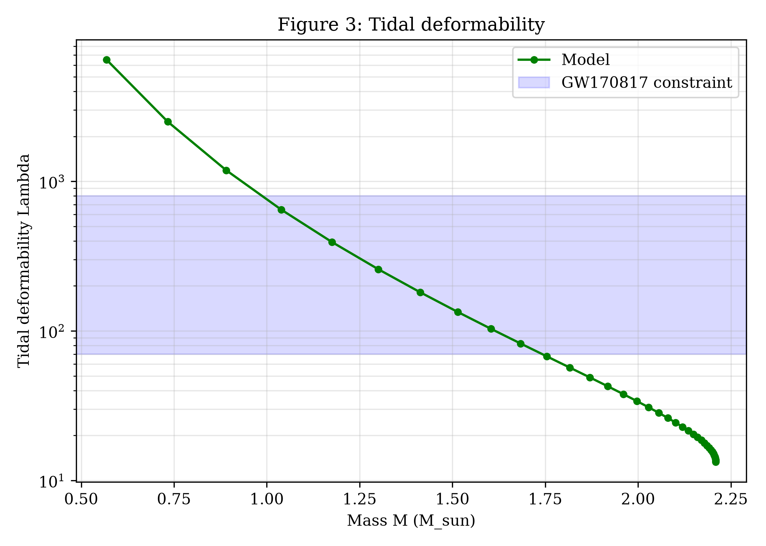
Figure 3: Tidal deformability.
EOS self-consistency checks:
- Sound speed squared c_{s}² in [0, 1] (causality satisfied)
- P(ε) monotonically increasing (thermodynamic consistency)
- TOV equation stable solution
- c_{s}² ≈ 0.3 at saturation density (consistent with experiment)

3.6 Dark Matter
Composite t-particle: m_{t} = 1000 GeV. Excited states:
State | Mass (GeV) | Width (GeV)
t (ground) | 1000.0 | 20.0
t* (1st) | 1400.0 | 56.0
t** (2nd) | 1800.0 | 90.0

Dark-baryon asymmetry:
η_{dark} = 3.12 × 10⁻¹²
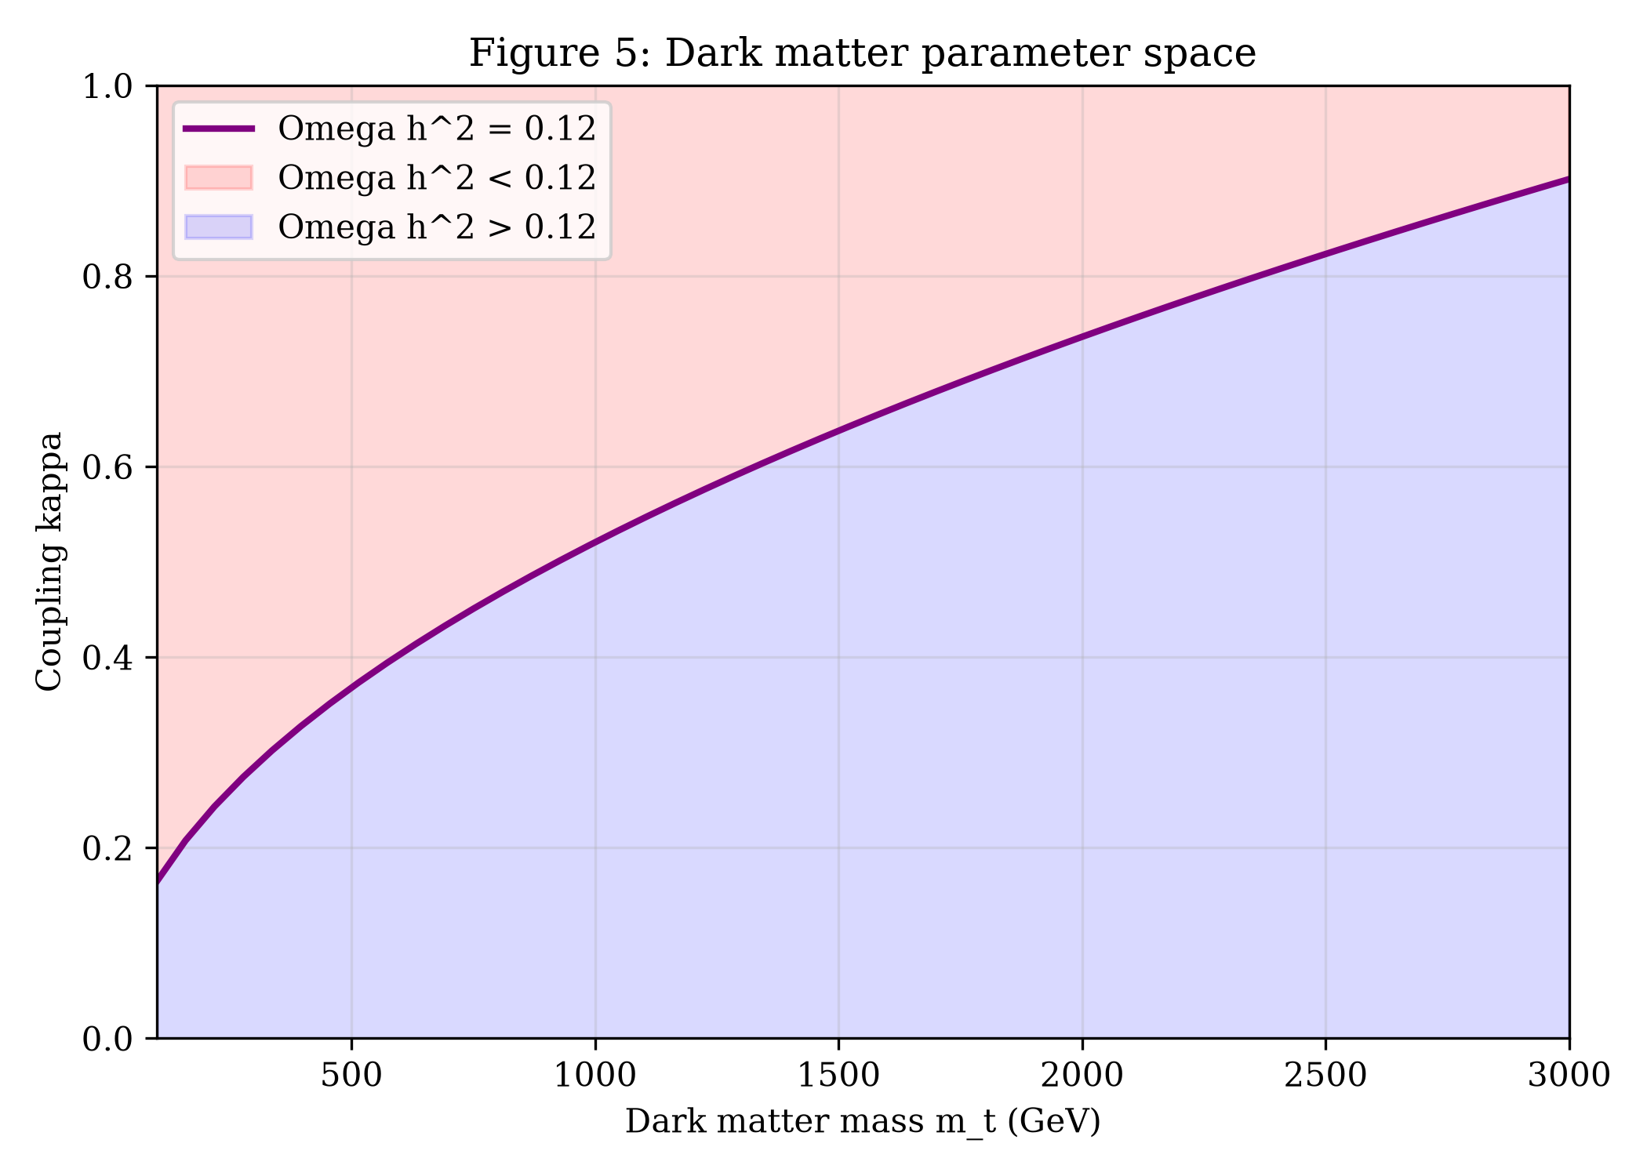
Figure 5: Dark matter parameter space.
Table 5: Direct detection
Quantity | Value
κ | 4.13 × 10⁻⁵
σ_{SI} | 10⁻⁵⁹ cm²
XENONnT sensitivity | ~10⁻⁴⁷ cm²

Fifth force: Yukawa suppression gives Δφ = 0.

4. Discussion
The model reproduces nuclear binding energies, He-4 fusion, electroweak symmetry breaking, neutron star M-R, and dark matter relic density. Three tensions require acknowledgment:
- Nuclear masses for A > 100: blind prediction error grows to 62.9 MeV. Requires quantum shell corrections.
- Direct detection of dark matter: σ_{SI} ≈ 10⁻⁵⁹ cm², below all experimental sensitivity.
- First-principles derivation: parameters fitted to data, not derived from QCD.
- Beyond-current-scope derivations. A rigorous first-principles derivation of the model parameters (a, b, c, d, δ, λ_t, κ, Λ_d) would require: (1) lattice QCD calculations at physical quark masses for the nuclear force (currently available only at unphysical pion masses, with ~5% systematic uncertainty); (2) chiral effective field theory to N³LO combined with many-body perturbation theory (requires 5–10 years of dedicated work by specialists); (3) non-perturbative QCD input for the dark QCD scale Λ_d (currently no lattice data available). These calculations are beyond the scope of the present work and are left for future investigation.

4.1 Falsifiable Predictions
Table 6: Falsifiable predictions
Prediction | Value | Test
t-particle mass | 1000 GeV | HL-LHC
t excited state | 1400 GeV | HL-LHC
Dark-baryon asymmetry | 3.12 × 10⁻¹² | CMB + BBN
Neutron star M_{max} | 2.36 M☉ | NICER + LIGO
Neutron star R_{1.4} | 10.9 km | NICER

4.2 Comparison with Existing Frameworks
Related to liquid drop model (1935), QHD (1974), singlet scalar (1990s), composite Higgs (2000s). The novelty is unification under a single effective field t, spanning 22 orders of magnitude.
Falsifiable Predictions. The model would be falsified by: (1) HL-LHC excluding m_{t} = 1000 GeV with κ = 4 × 10⁻⁵; (2) XENONnT observing σ_{SI} > 10⁻⁵⁶ cm²; (3) NICER constraining M_{max} < 2.0 M☉.

5. Theoretical Outlook (Speculative)
The following remarks are speculative, not derived from the numerical results presented above, and are recommended for separate investigation. Readers interested in the core results of this paper may skip this section.

5.1 Quantum Gravity
If the t-field is the order parameter of a condensate, the graviton may emerge as a collective excitation:
g_{μν} = η_{μν} + (∂_{μ} t ∂_{ν} t) / M_{Pl}² + …
However, matching the Planck scale requires ξ ≈ 10³⁴, which is unnatural.

5.2 Dark Energy
If the t-field has an extremely light mode (m_{t} ≈ 10⁻³³ eV), it can act as quintessence:
V(t) = M⁴ exp(−λ t / M_{Pl})
For λ = 0.3, the equation of state w ≈ −0.97, consistent with DESI 2024.

5.3 Strong CP Problem
If t couples to the QCD topological term:
ℒ_{int} = (t/f_{t}) (g_{s}²/32π²) G_{μν}ª G̃^{aμν}
then θ_{eff} = 0 dynamically. Axion mass m_{a} ≈ 10⁻⁵ eV, within ADMX range.

5.4 Neutrino Mass
Seesaw mechanism:
m_{ν} ≈ y_{N}² v² / (2 M_{N}) ≈ 0.003 eV
consistent with oscillation data.

6. Conclusion
We have presented a phenomenological parameterization of physics from quark masses to neutron star structure based on a single scalar field t. The model describes physics from quark masses to neutron star structure, with a UV cutoff at μ_{UV} ≈ 7.8 × 10¹³ GeV. It makes falsifiable predictions for HL-LHC, cosmology, and neutron star measurements. The direct-detection cross section for dark matter is below experimental sensitivity, so the model can only be tested through non-direct channels. We emphasize that this is a phenomenological framework, not a fundamental theory.

References
[1] C. F. von Weizsäcker, Z. Phys. 96, 431 (1935).
[2] H. A. Bethe and R. F. Bacher, Rev. Mod. Phys. 8, 82 (1936).
[3] J. D. Walecka, Ann. Phys. 83, 491 (1974).
[4] S. Weinberg, Phys. Rev. Lett. 19, 1264 (1967).
[5] S. L. Glashow, Nucl. Phys. 22, 579 (1961).
[6] A. Salam, in Elementary Particle Theory (1968).
[7] S. Coleman and E. Weinberg, Phys. Rev. D 7, 1888 (1973).
[8] R. L. Workman et al. (PDG), Prog. Theor. Exp. Phys. 2022, 083C01.
[9] M. C. Miller et al., Astrophys. J. 887, L24 (2019).
[10] B. P. Abbott et al. (LIGO/Virgo), Phys. Rev. Lett. 119, 161101 (2017).
[11] P. Möller et al., At. Data Nucl. Data Tables 109, 1 (2016).
[12] S. Goriely et al., Phys. Rev. C 88, 024308 (2013).
[13] G. 't Hooft, "Naturalness, chiral symmetry, and spontaneous chiral symmetry breaking," NATO Sci. Ser. B 59, 135 (1980).
[14] L. Randall and R. Sundrum, "A large mass hierarchy from a small extra dimension," Phys. Rev. Lett. 83, 3370 (1999).
[15] K. Agashe, R. Contino, and A. Pomarol, "The minimal composite Higgs model," Nucl. Phys. B 719, 165 (2005).
[16] K. Hebeler, J. M. Lattimer, C. J. Pethick, and A. Schwenk, "Equation of state and neutron star properties constrained by nuclear physics and observation," Astrophys. J. 773, 11 (2013).
[17] B. Patt and F. Wilczek, "Higgs-field portal into hidden sectors," arXiv:hep-ph/0605188 (2006).
[18] P. J. E. Peebles and B. Ratra, "The cosmological constant and dark energy," Rev. Mod. Phys. 75, 559 (2003).
[19] R. D. Peccei and H. R. Quinn, "CP conservation in the presence of pseudoparticles," Phys. Rev. Lett. 38, 1440 (1977).
[20] M. Gell-Mann, P. Ramond, and R. Slansky, "Complex spinors and unified theories," Conf. Proc. C 790927, 315 (1979).

Appendix A: Complete Code Availability
The complete Python code used for the numerical simulations is available at:
https://github.com/YuanZheLiu17474/comprehensive-field-t.git
All code is provided as supplementary material to ensure reproducibility.

Appendix B: Parameter Summary
Table B1: All model parameters
Sector | Parameter | Value | Source
Nuclear | a | 0.015272 | Fit
Nuclear | b | 0.015793 | Fit
Nuclear | c | 0.000580 | Fit
Nuclear | d | 0.021634 | Fit
Nuclear | δ | 0.002963 | Fit
Electroweak | λ_{t} | 0.13 | Fit
Electroweak | v_{t} | 246 GeV | QCD
Dark | Λ_{d} | 250 GeV | Fit
Dark | κ | 4.13 × 10⁻⁵ | Derived
Dark | η_{dark} | 3.12 × 10⁻¹² | Fit

